1.Two sum

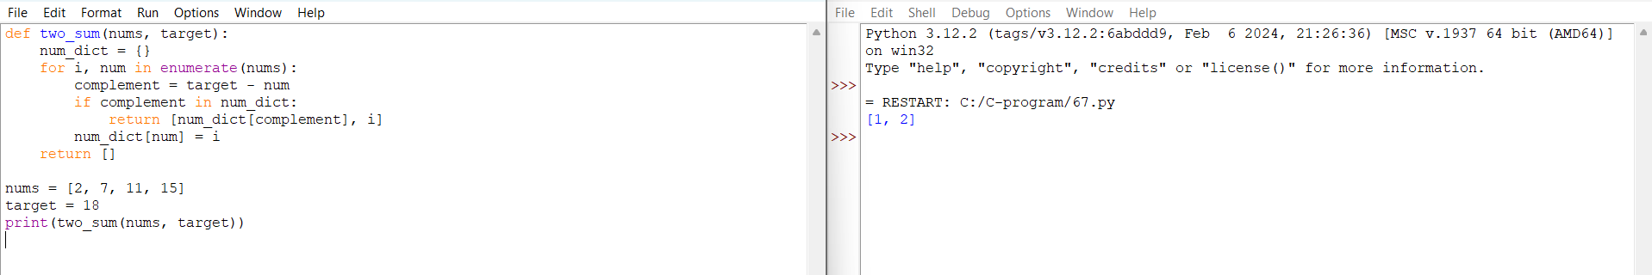

2.Add Two Numbers

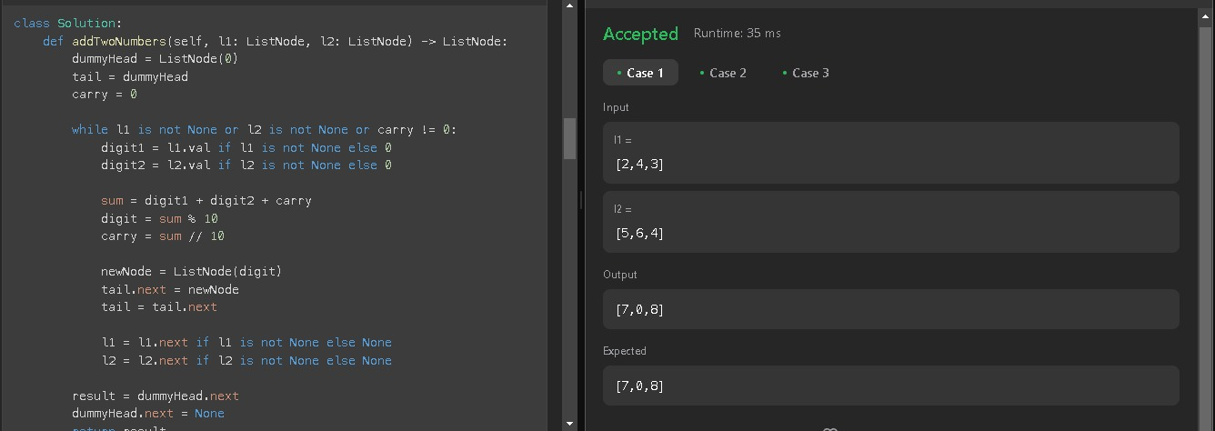

3.Longest Substring without Repeating Characters

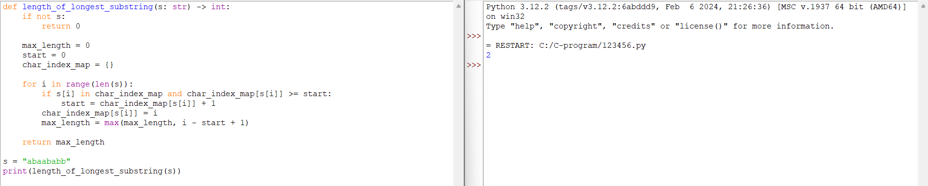

4.Median of Two Sorted Arrays

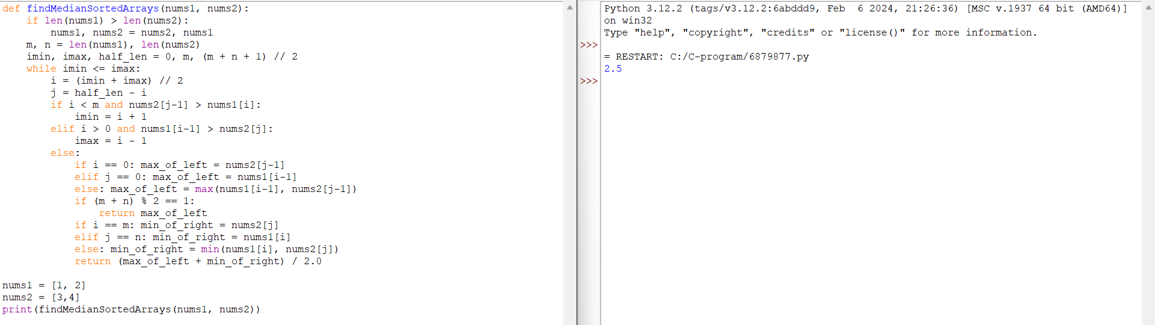

5.Longest Palindromic Substring

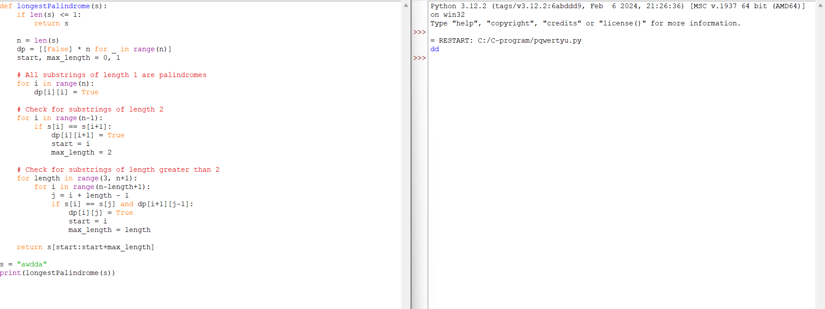

6.ZigZag

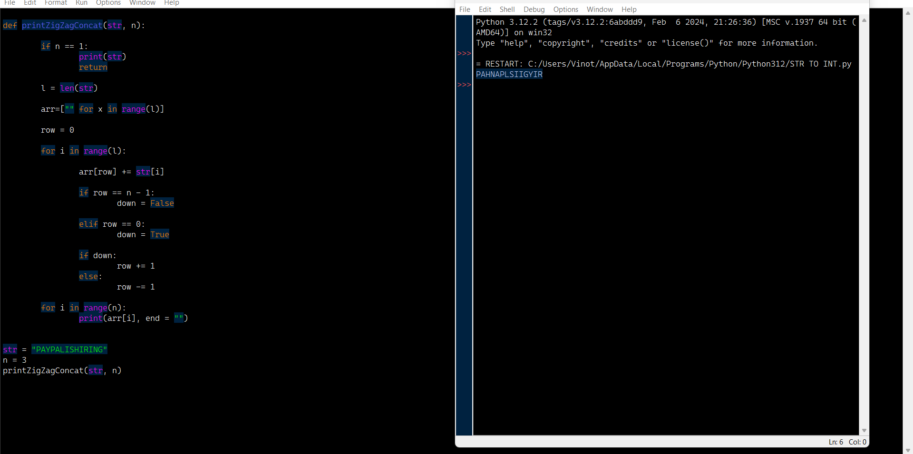

7.Reverse Integer



8.String to Integer

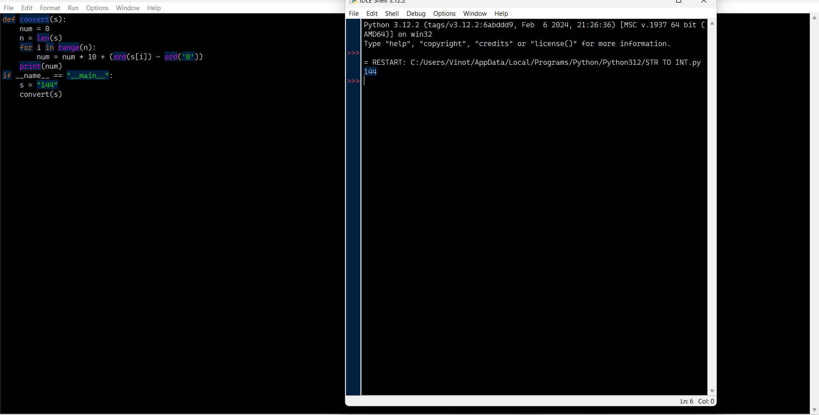

9.Palindrome Number

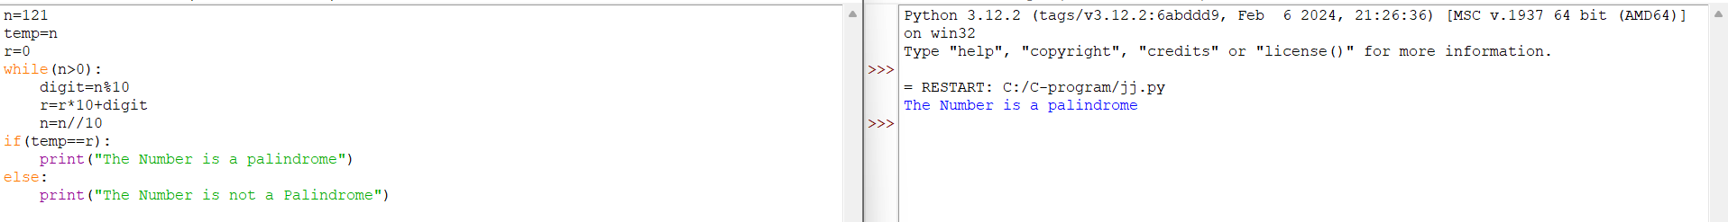

10. Regular Expression Matching

